| **PROJECT TITLE** | **RESTAURANT ANALYSIS OF SWIGGY** |
| --- | --- |

horizontal line

# Placeholder image

# Introduction

The aim is to analyze and visualize restaurant data to extract meaningful insights that can help in making informed business decisions usingPower BI to create interactive dashboards showcasing various aspects of the restaurant's performance.

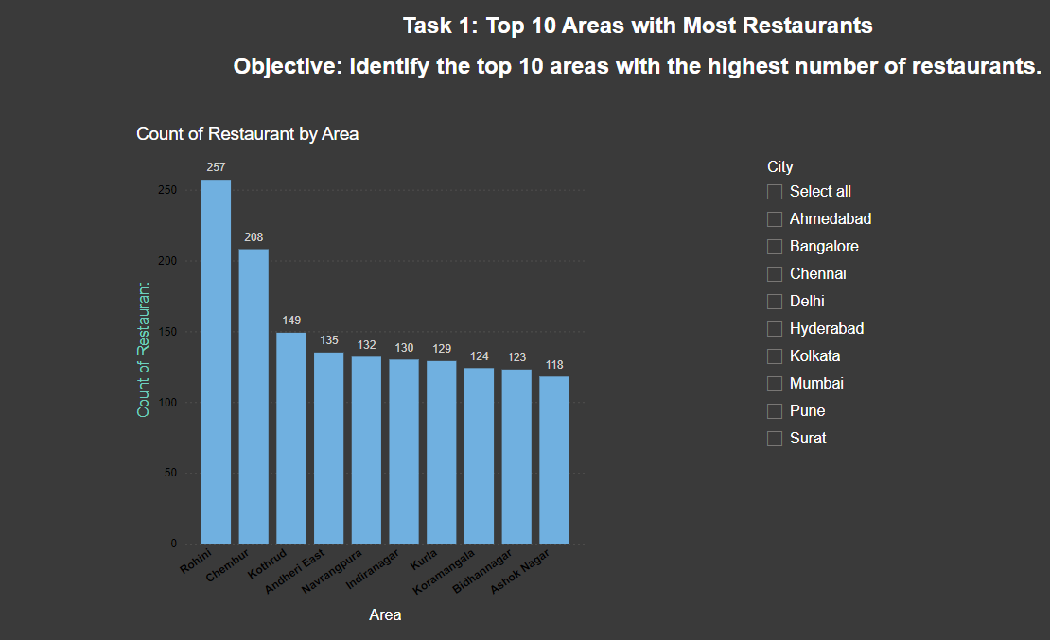

### 

### Task 1: Top 10 Areas with Most Restaurants

**Objective: Identify the top 10 areas with the highest number of restaurants.**

**Top 10 Areas with Most Restaurants:**

1. **Rohini: 257 restaurants**
2. **Chambur: 208 restaurants**
3. **Kothrud: 149 restaurants**
4. **Andheri East: 135 restaurants**
5. **Navrangpura: 132 restaurants**
6. **Indiranagar: 130 restaurants**
7. **Kurla: 129 restaurants**
8. **Koramangala: 124 restaurants**
9. **Bidhannagar: 123 restaurants**
10. **Ashok Nagar: 118 restaurants**

**Insights:**

* **Rohini has the highest number of restaurants, with 257 establishments.**
* **Chambur is the second-highest with 208 restaurants.**
* **The top 10 areas have a significant concentration of restaurants, ranging from 118 to 257.**
* **These areas likely attract a large customer base and have high demand for dining options.**

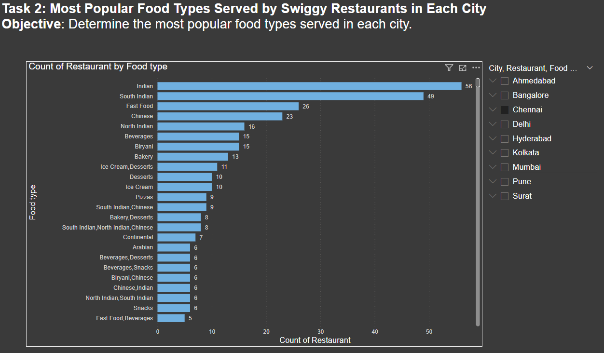

**Task 2: Most Popular Food Types Served by Swiggy Restaurants in Each City**

**Objective: Determine the most popular food types served in each city.**

**Based on the provided image, the following food types can be identified:**

* **Main Courses: South Indian, North Indian, Chinese, Biryani, Continental, Arabian, Chettinad**
* **Snacks: Snacks**
* **Beverages: Beverages, Juices**
* **Desserts: Desserts, Ice Cream, Sweets**

**Key Findings:**

* **South Indian Cuisine is the most popular with 49 restaurants, indicating a strong preference for this cuisine.**
* **Fast Food and Chinese cuisines follow closely behind with 26 and 23 restaurants respectively.**
* **Beverages, Biryani, and North Indian cuisines have a similar popularity level with around 15-16 restaurants each.**
* **Desserts, Ice Cream, and Bakery items are also popular with around 10-13 restaurants.**

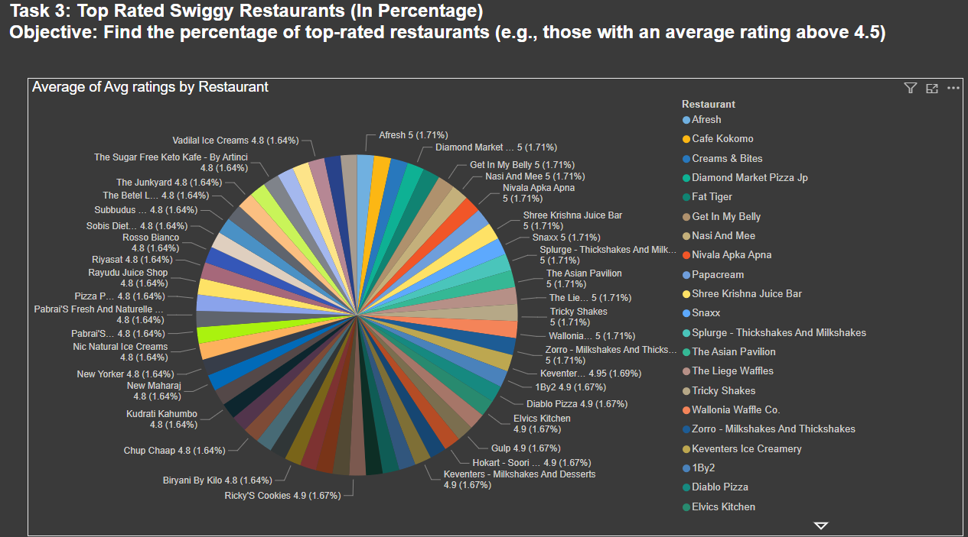

**Task 3: Top Rated Swiggy Restaurants (In Percentage)**

**Objective**: Find the percentage of top-rated restaurants (e.g., those with an average rating above 4.5).

* **Key Finding**: Most restaurants have high ratings (4.8-5).
* **Insight**: This suggests strong customer satisfaction, indicating a competitive market where quality and service are crucial.

To determine the percentage of top-rated restaurants (those with an average rating above 4.5), we need to sum up the percentages of slices representing ratings higher than 4.5.

**Key Insights:**

* A significant portion of restaurants on Swiggy boast an average rating of 5.0, indicating a high level of customer satisfaction.
* Restaurants with ratings between 4.8 and 4.9 also constitute a substantial percentage, suggesting a generally positive customer experience.
* A smaller but still notable proportion of restaurants have ratings between 4.5 and 4.8, indicating a decent level of customer satisfaction.

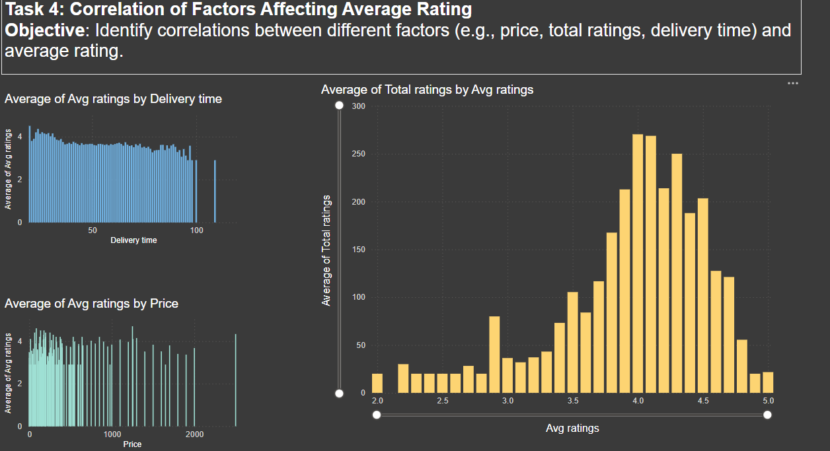

**Task 4: Correlation of Factors Affecting Average Rating**

**Objective: Identify correlations between different factors (e.g., price, total ratings, delivery time) and average rating.**

**The provided image displays two charts:**

* **Average of Avg Ratings by Delivery Time: This chart appears to show the distribution of average ratings across different delivery times. However, the x-axis is not clearly labeled, making it difficult to interpret the data accurately.**
* **Average of Avg Ratings by Price: This chart depicts the distribution of average ratings across different price points. The x-axis represents price, and the y-axis represents the average rating.**
* **Key Finding: No strong correlation between price, total ratings, delivery time, and average ratings.**
* **Insight: Other factors like food quality, service, and ambiance might play a larger role in customer satisfaction.**

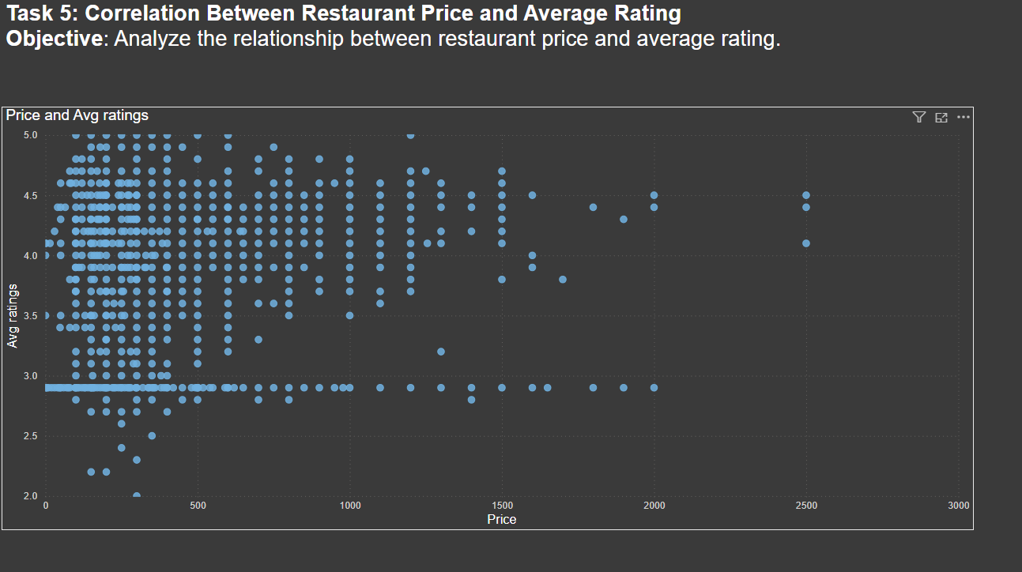

**Task 5: Correlation Between Restaurant Price and Average Rating**

**Objective: Analyze the relationship between restaurant price and average rating.**

**The x-axis represents the price of the restaurant ( the average price per meal), and the y-axis indicates the average rating the restaurant has received. Each data point represents a single restaurant.**

**The scatter plot also reveals some interesting outliers. There are some high-priced restaurants with lower average ratings and vice versa. This suggests that price is just one factor influencing average rating, and other factors can play a significant role.**

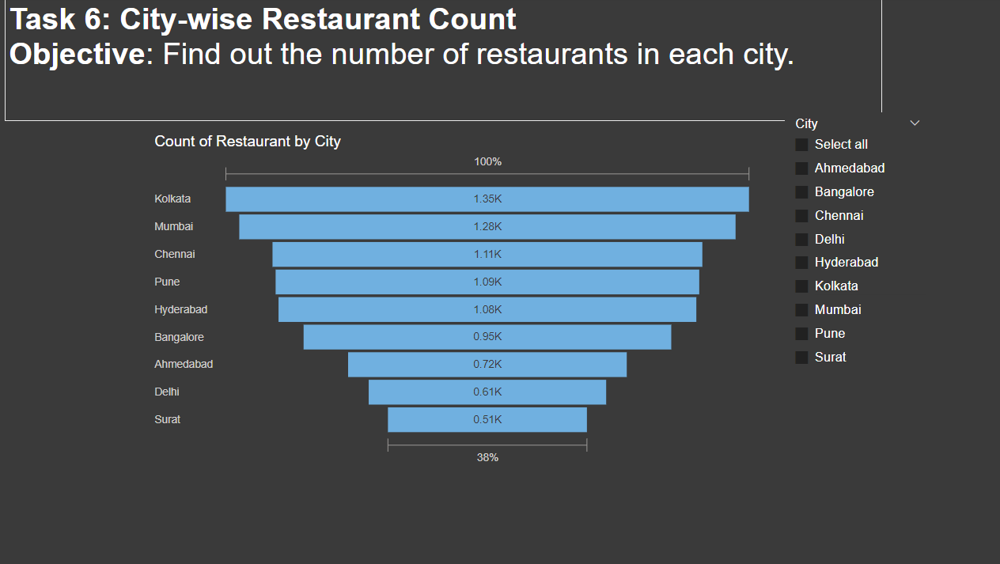

**Task 6: City-wise Restaurant Count**

**Objective: Find out the number of restaurants in each city.**

**Analysis:**

**The x-axis represents the city, and the y-axis shows the number of restaurants in that city. Here's a breakdown of the number of restaurants in each city:**

* **Ahmedabad: 720 restaurants**
* **Bangalore: 950 restaurants**
* **Chennai: 1,110 restaurants**
* **Delhi: 610 restaurants**
* **Hyderabad: 1,080 restaurants**
* **Kolkata: 1,350 restaurants**
* **Mumbai: 1,280 restaurants**
* **Pune: 1,090 restaurants**
* **Surat: 510 restaurants**

**Insights:**

* **Kolkata has the most restaurants (1,350), followed by Mumbai (1,280) and Chennai (1,110). This suggests that these cities have a large and diverse culinary scene, potentially due to a high population density or a strong culture of eating out.**
* **Ahmedabad (720) and Surat (510) have a lower number of restaurants compared to the other metro cities. This could indicate a smaller market size or a different food culture where people eat out less frequently.**

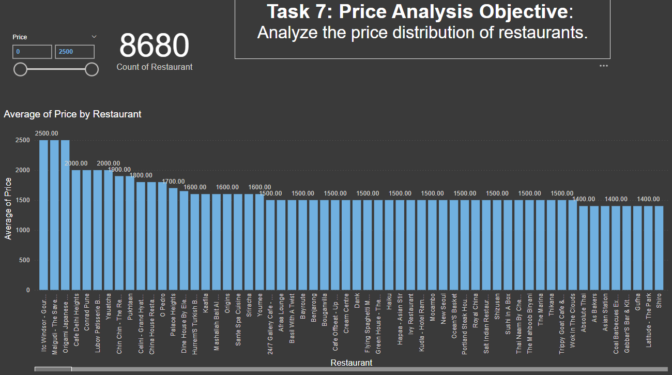

**Task 7: Price Analysis**

**Objective: Analyze the price distribution of restaurants.**

**Data Analysis**

**It presents a histogram with the price of restaurants on the x-axis and the count of restaurants on the y-axis.**

* **The price seems to be distributed across a wide range, likely starting from 500 and possibly extending up to 2000 or more.**
* **There appears to be a concentration of restaurants in the lower and middle price ranges (between 500 and 1500). This suggests that a significant portion of the restaurants cater to budget-conscious customers.**
* **While the exact counts are difficult to determine from the image, it seems there are fewer restaurants in the higher price ranges (above 1500).**
* **Calculate summary statistics: Find the average, median, and standard deviation of restaurant prices.**
* **Segment the data by cuisine type: Analyze the price distribution within different cuisine categories. This can help identify price trends within specific cuisines.**

**By combining these analyses, businesses can gain a more understanding of the restaurant price landscape and make informed decisions to optimize their offerings and target the right customer.**

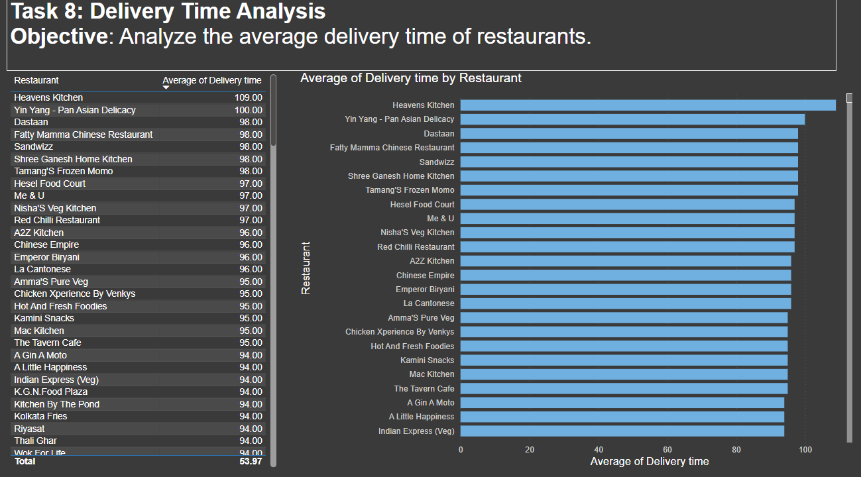

**Task 8: Delivery Time Analysis**

**Objective: Analyze the average delivery time of restaurants.**

* **Average Delivery Time Range: The average delivery time for the listed restaurants falls between 94 and 109 minutes.**
* **Delivery Time Distribution: Most restaurants have an average delivery time clustered between 94 and 98 minutes.**
* **Top Performers: Heavens Kitchen has the highest average delivery time at 109 minutes, while Wok For Life has the lowest at 94 minutes.**

### Insights

* **Delivery Time Consistency: The relatively narrow range of delivery times suggests a certain level of consistency among the listed restaurants.**
* **Potential for Improvement: Restaurants with delivery times exceeding the average (95.37 minutes) might consider strategies to reduce their delivery time to improve customer satisfaction.**
* **Customer Satisfaction: Lower delivery times are generally correlated with higher customer satisfaction. Restaurants with consistently shorter delivery times could potentially gain a competitive advantage.**

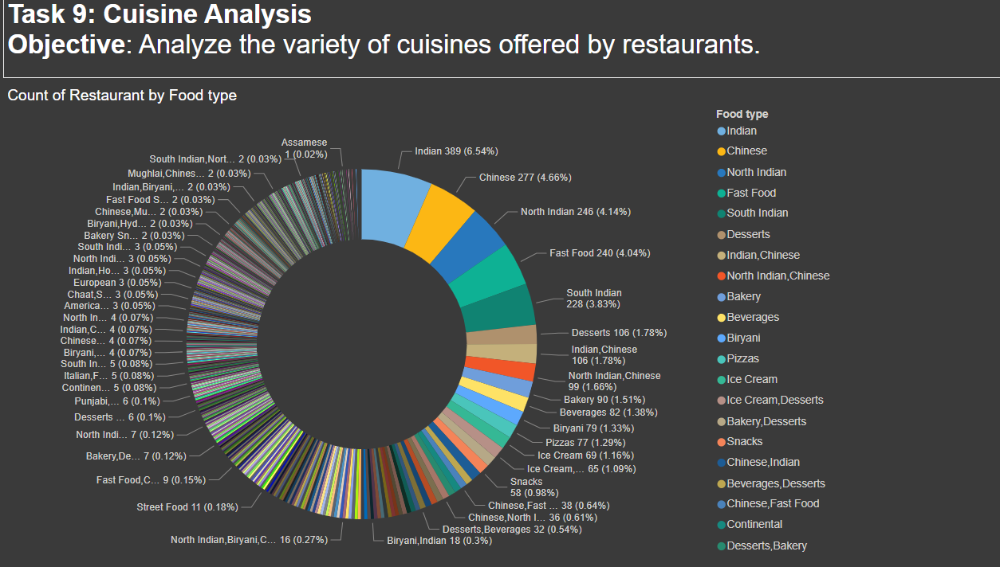

**Task 9: Cuisine Analysis**

**Objective: Analyze the variety of cuisines offered by restaurants.**

**The image you sent displays a table titled "Count of Restaurant by Food Type." It categorizes restaurants based on the cuisine they offer.**

**Indian: The dominant cuisine with 389 restaurants (6.54%). This is further broken down into sub-categories like South Indian, North Indian, Mughlai, Chettinad, Biryani, and Assamese.**

* **Chinese: The second most popular cuisine with 277 restaurants (4.66%).**
* **Fast Food: The third most common category with 240 restaurants (4.04%).**
* **South Indian: 106 restaurants (1.78%)**

**Key Insights**

* **Indian Cuisine Dominance: Indian cuisine is clearly the most popular choice, likely reflecting a preference for local flavors. The breakdown into sub-categories suggests a diverse range of Indian food options available.**
* **Chinese Cuisine Popularity: Chinese cuisine holds a strong position, indicating a demand for East Asian flavors.**
* **Fast Food Presence: The presence of a dedicated "Fast Food" category signifies the popularity of convenient and quick meal options.**

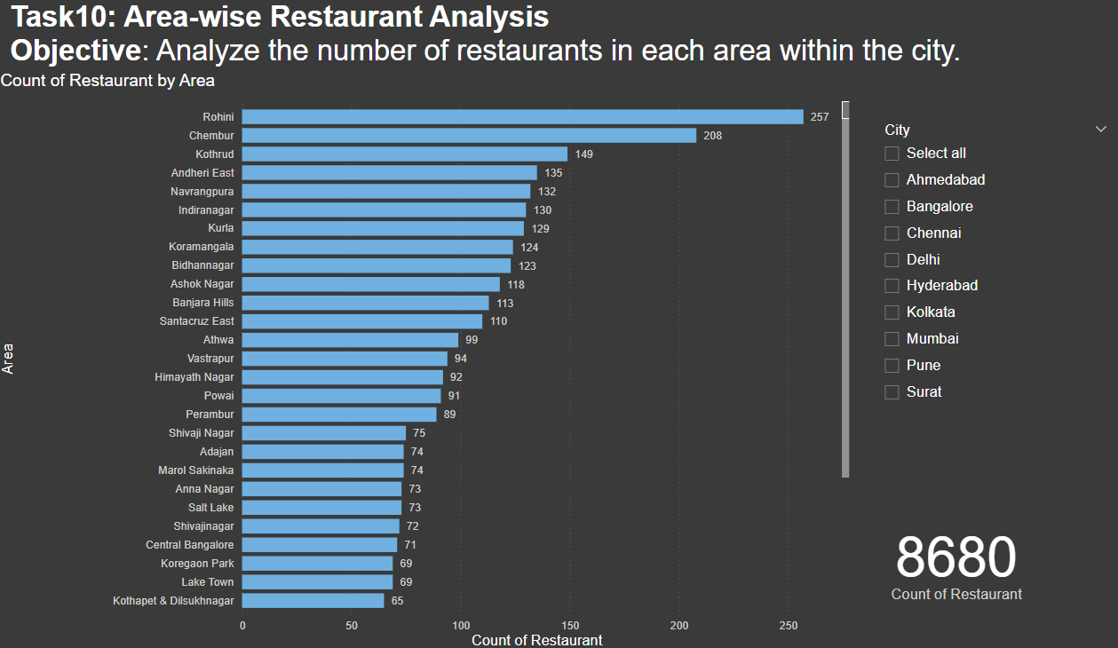

**Task 10: Area-wise Restaurant Analysis**

**Objective: Analyze the number of restaurants in each area within the city.**

**Key Findings:**

* **Rohini is the area with the highest number of restaurants, totaling 257.**
* **Chambur follows closely with 208 restaurants.**
* **There's a significant drop in restaurant count after the top two areas.**
* **The distribution of restaurants across areas is relatively skewed, with a few areas having a considerably higher number of restaurants compared to others.**
* **Areas with High Restaurant Density: Rohini and Chambur appear to be culinary hubs within the city, attracting a larger customer base.**
* **Potential for Expansion: Areas with a lower number of restaurants might present opportunities for new restaurant openings.**
* **Customer Demand: The distribution of restaurants can reflect the population density and consumer preferences in different areas.**

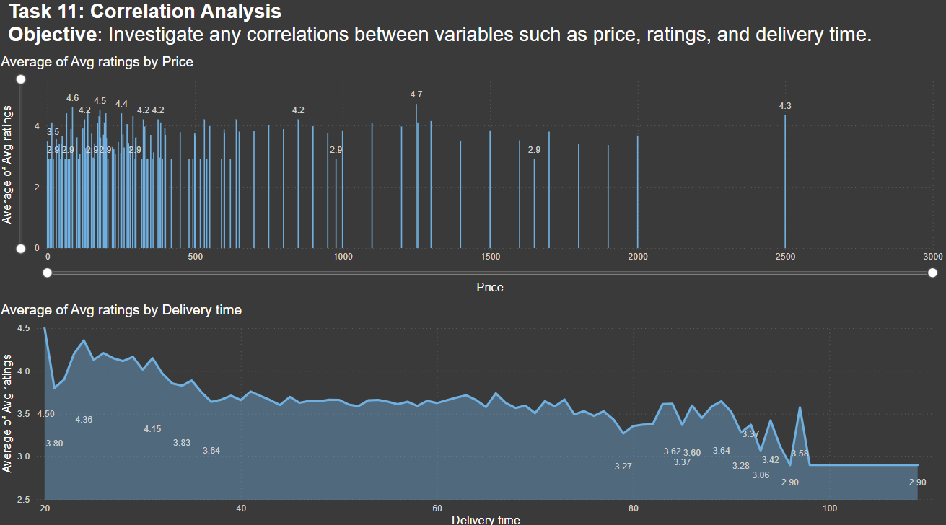

**Task 11: Correlation Analysis**

**Objective: Investigate any correlations between variables such as price, ratings, and delivery time.**

**The image presents two charts:**

1. **Average of Avg Ratings by Price: This chart displays the average rating for different price ranges.**
2. **Average of Avg Ratings by Delivery Time: This chart shows the average rating for different delivery time intervals.**

**Insights**

**1. Average of Avg Ratings by Price**

* **No Clear Correlation: There appears to be no strong correlation between price and average rating. The data points are scattered without a clear upward or downward trend.**
* **A few data points with exceptionally high average ratings exist at various price points, indicating that price alone cannot explain the variation in ratings.**

**2. Average of Avg Ratings by Delivery Time**

* **Negative Correlation: There seems to be a slight negative correlation between delivery time and average rating. As delivery time increases, the average rating tends to decrease. However, the relationship is not very strong, and there are significant fluctuations.**
* **Other factors, such as order volume, restaurant popularity, and cuisine type, might influence the relationship between delivery time and ratings.**

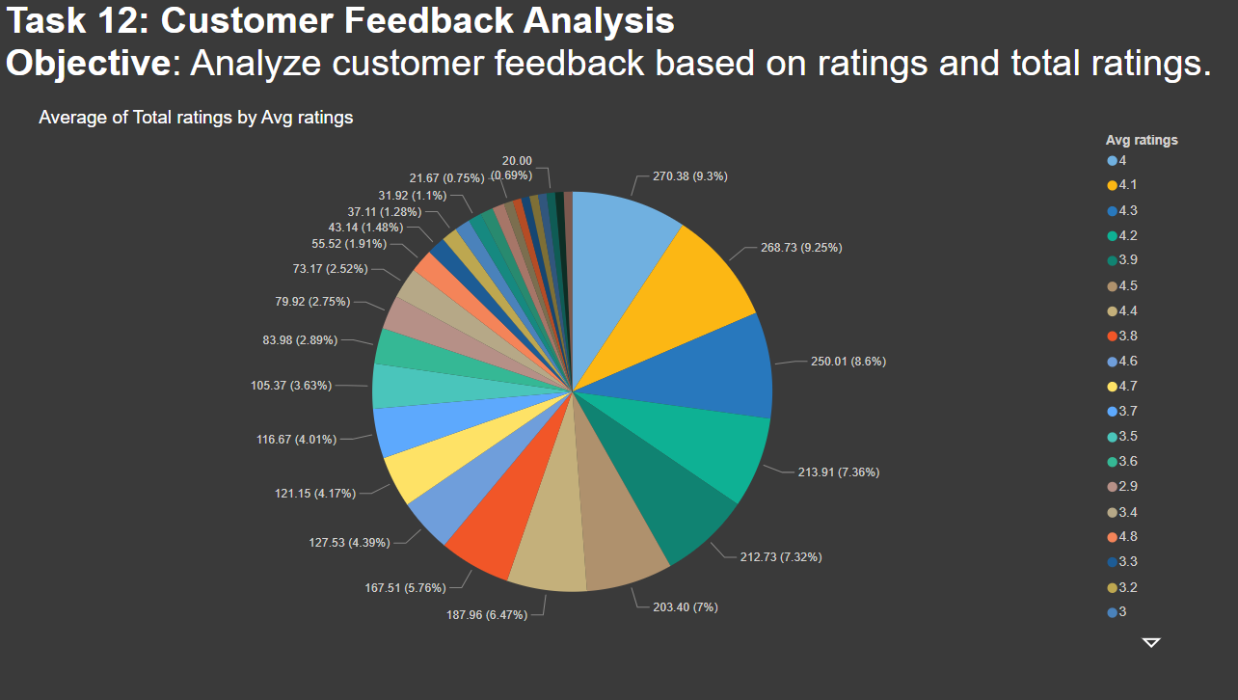

**Task 12: Customer Feedback Analysis**

**Objective: Analyze customer feedback based on ratings and total ratings.**

### Data Analysis

**The provided pie chart illustrates the distribution of total ratings across different average rating categories. Each slice represents a specific average rating range, and its size corresponds to the percentage of total ratings falling within that range.**

### Key Insights

* **Concentration in Higher Ratings: A significant portion of total ratings is concentrated in the higher average rating categories (4.5 to 5.0). This indicates a general satisfaction among customers.**
* **Distribution Tail: The distribution has a long tail towards lower ratings, suggesting that while most customers are satisfied, there's a segment with lower satisfaction levels.**
* **Rating Categories: The chart provides a granular view of the rating distribution, allowing for a deeper understanding of customer sentiment.**

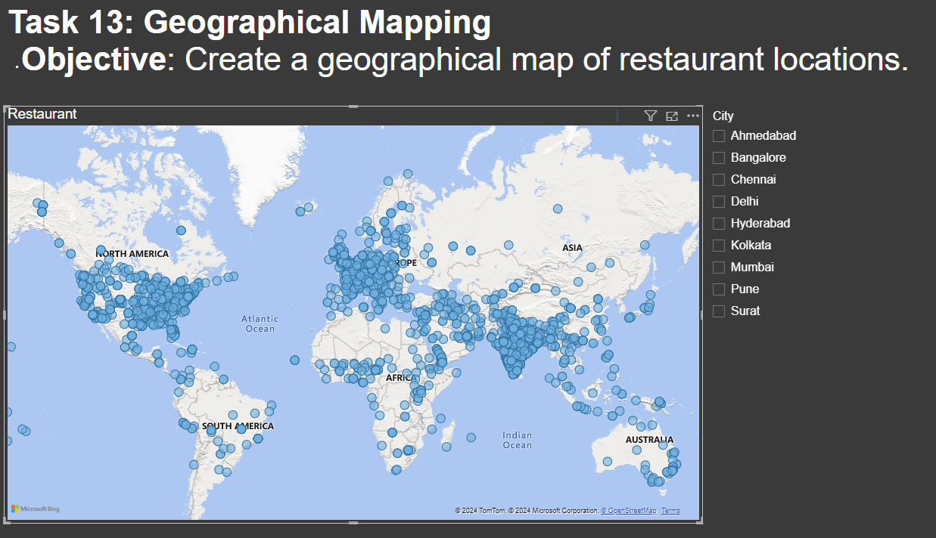

**Task 13: Geographical Mapping**

**Objective: Create a geographical map of restaurant locations.**

* **Restaurant Distribution: The blue dots are clustered in specific areas, indicating a higher concentration of restaurants in those regions.**
* **City Representation: The list of cities includes Ahmedabad, Bangalore, Chennai, Delhi, Hyderabad, Kolkata, Mumbai, Pune, and Surat.**
* **Map Clarity: The map appears to be a world map, but the specific focus seems to be on the Asian continent.**
* **Data Limitations: The image doesn't provide specific details about the restaurants, such as their names or types.**

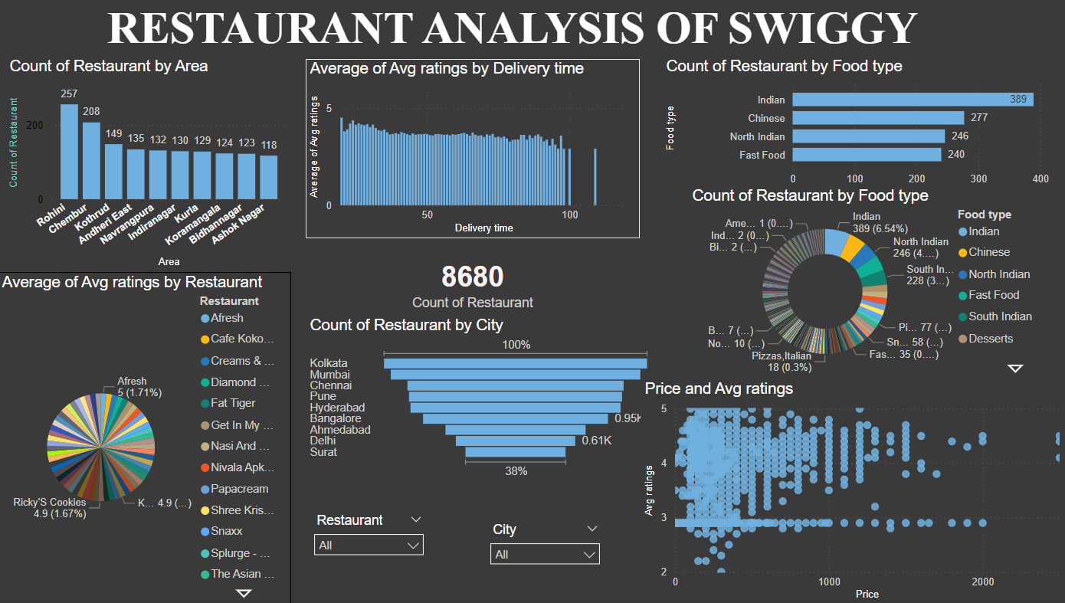

**Task 14: Business Recommendations**

**Recommendations:**

* + **Focus on High-Performing Areas: the popularity of Rohini and Chembur by ensuring top service quality to maintain market share.**
  + **Quality: Maintain high standards of food quality and service, as these seem to be more critical to customer satisfaction than price or delivery time.**
  + **Customer Feedback Utilization: Use customer feedback for continuous improvement, focusing on aspects beyond just price and ratings.**